**Project Final Report**

**Housing Code Violation Search System (Web App)**

The Hit Wonders Consulting Team, Syracuse University

The Innovation Team, City of Syracuse

Zezheng Jiang, Hit Wonders member, Email: [zjian107@syr.edu](mailto:zjian107@syr.edu)

Zequn Che, Hit Wonders member, Emial:zche100@syr.edu

Sam Edelstein, Chief Data Officer, Email: sedelstein@syrgov.net

Adria Finch, Chief Innovation Officer, Email: afinch@syrgov.net

Address: 233 E Washington St, Syracuse, NY 13202

Website: http://www.innovatesyracuse.com/

Phone number: (315) 448-8005

About the Agency

The Innovation Team (i-team) staffs the Office of Accountability, Performance, & Innovation (i-team API). The Office contains three divisions:

* The Data Division works with departments to better understand and use data to drive decision-making.
* The Innovation Division partners with departments to develop new & creative solutions to address challenges and improve operations.
* The Accountability Division works with departments to ensure the ongoing advancement of programs and policies.

The i-team API also established a Performance Management Program to inform and improve operations. As part of this plan, the three divisions work with Departments to achieve specific mayoral objectives.

In the Project, the board members are Chief Data Officer, Sam Edelstein, and Chief Innovation Officer, Adria Finch. The agency is the local government with jurisdiction over the City of Syracuse, serving the more than 145,000 residents as well as those who work and visit. Team Hit Wonders, including two students, Daniel Zezheng Jiang and Zequn Che from the School of Information Studies at Syracuse University, is responsible for the project. Hit Wonders aims to increase web accessibility and functionality for the client.

The Problem

We need to reconstruct a website to have a good appearance and strong functionalities based on the previous developers’ work.

The website is for people who are looking forward to living in Syracuse, NY. Users can search the code violation history of houses with address information. The code violation data is from Syracuse Open Data, which is a code violation history data hub. Clients want to serve more people in Syracuse by providing a great and convenient housing searching tool.

Missions include improving search bar, connecting with APIs, and re-designing the web.

Stakeholders

The stakeholders of the project are Sam Edelstein, Chief Data Officer, and Adria Finch, Chief Innovation Officer of the Innovation Team. Since it is also a capstone project for students who are graduating soon from Syracuse University, the Hit Wonders team is responsible for the capstone professor Marcene Sonneborn.

Scope

The Project

The project constructs a code violation history retrieve system which has a great appearance and multiple reliable functionalities. We remain previous developers’ work to keep the original search functionality, mainly written in JavaScript programming language.

Description of the Product

When a user inputs the desired address, the search bar will have limited ten results of the autocomplete address. By hitting the “Enter” button, there will be a list of housing violation history related to that address. The online tool can help housing renters or buyers to evaluate housing more accurately.

Hit Wonders aims to develop the Web App by adding new functions. The website and user interface should be more user-friendly. The search bar should have the autocomplete function to help the user input their address quickly. The most updated data should come from APIs and should not be downloaded as files.

Main Missions

We need to redesign the website, build the searching bar with autocomplete function, and connect the website to the official APIs from the local government.

Firstly, the redesign of the website is a very important mission. The original website is old-fashion and unclear for the visitors. The user interface of the original website is unfinished. For making the website readable and accessible:

* The new user interface should be neat and pleasing.
* The new user interface should follow the branding guidelines from the agency.

Secondly, the most significant function of the website is searching. It searches input and pushes data back to users after pressing the “Enter” key.

The feature above is the basic function of a search bar. In our project, we need a more advanced search bar that could do the auto-completion. Auto-completion is a very useful and convenient function for users. It makes the searching process easier and faster.

Thirdly, the API connection is a very practical development for the website. In the previous version of the website, it connects with an API and downloads housing and code violation history data into a “csv” file. Then it uses a data document as the database. The old method needs to improve because the application can read data directly from API instead of the file created.

There are many advantages to use API but not data documents:

* The API makes searching faster.
* The API makes users always get the newest data from the internet.
* The web server has lower loads.

In summary, the three main missions of the project are website redesigning, search bar, API connection. When these three missions are completed, the project will be finished.

Issues & Opportunities

The main issues of the project are the difficulty of coding. We are familiar with HTML and CSS. However, the main programming languages are HTML, CSS, JavaScript. JavaScript is a new language for us. We need to spend some time to learn and use it. As a result, learning is the most time-consuming part of the project.

The opportunities in the project are also learning. By learning the new languages, we are expanding our skills into another level because JavaScript is one of the most popular languages. Hit Wonder team is honored to solve a real-world problem while improving.

Questions in the First Meeting

In order to have a successful project, we ask many questions in the first meeting.

* “What is this website for?”
* “What kind of functions do we need on this website?”
* “Do we have any model to learn from?”
* “Can we get the codes of the previous version of the website?”
* “When should we have the regular meeting?”
* “At least, which kind of website should we build during the project?”
* “Do we have a clear target to follow?”

About the scope

Two members of Hit Wonders team and Sam Edelstein are developers, so we communicate easily. Both reached an agreement in the Scope document. Our scope mentioned all the key things and details which fulfill the agency’s needs.

Changes in the scope

There are no major changes during the project. However, we constantly look forward to making the project product better. We added more great things to our website. We made an animation background for the website which looks like a starry sky. It makes visitors to the website feel welcomed. It is a symbol of dynamic data that we are making on the website.

Plan and Implementation

There are 3 major change objectives: **API connection feature, search bar autocomplete feature** and **website graphic redesign**. We followed the timeline strictly to manage expectations between the Hit Wonder team and the Innovation team.

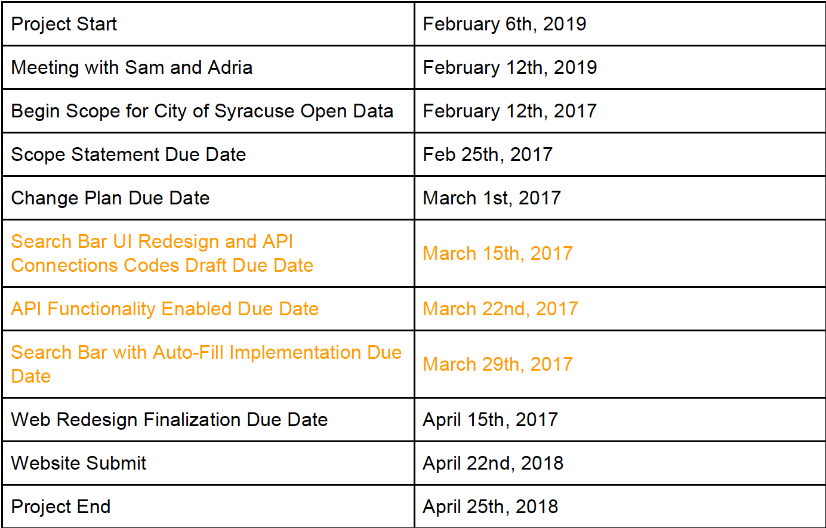

We have finished all the tasks by the time when the document is created. The highlighted texts are the most important part of the project, which focuses on functionality. Every new feature is developed within two weeks of duration.

Project Gantt Chart

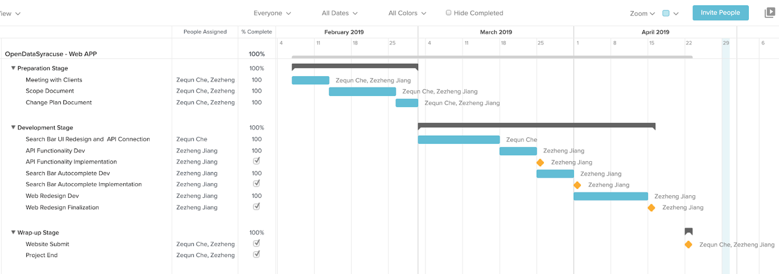

Major Project Assumptions

* All staff has a basic understanding of information technology involved.
* All defined deliverables in the scope are done within time and technology constraints.
* Constant communication between the Hit Wonders team and Innovation Team.
  + It is expected that Hit Wonders Team will actively communicate when there is an obstacle during the process of the project.

Risk and Cost Evaluation

There are no major risks of data breaches as the housing violation history information is public. There is also no extra cost because the API service is free.

Development

Each step is developed in different files to ensure there is no mutual interference between different development.

API Connection Feature

There are two API addresses for connections between the web app and the database. Both return result is shown in the JSON file format. By using keys and values in the JSON file, we can gain access to the data.

The first address fetching API ensures the autocomplete functionality pair with the data from the Parcel database, which includes the most updated address information, instead of code violation information.

The second code violation history fetching API is used from the original version. This API connects the web and the database so that it fetches the information from the code violation history database. It is important to build a liaison between two APIs, and ensure the fetched address information can be passed down to the second API to get code violation history information.

Search Bar Autocomplete Feature

We use jQueryUI Autocomplete for auto-complete function. For the users, this change can save their time typing, and they can choose a matched address from the database in a second. A quick search will increase web accessibility, and users can find information quickly, even with unfinished input from the user. The following shows the interface.

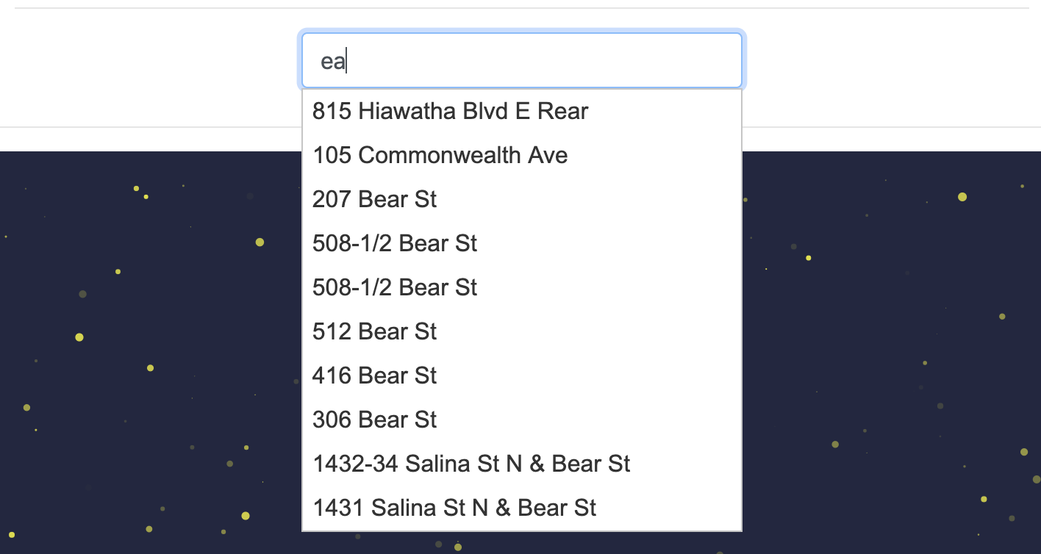

Website Graphic Redesign

It is the last part of the project because the functionality is considered a priority. The interface of the web is more modern, neat and user-friendly. We implement Bootstrap for quick web development. The design style follows the branding guideline provided by Adria Finch.

The main colors are blue, gold and white. The City Hall logo is also implemented on the page. The new web design increases web accessibility and the user will be more comfortable to navigate in the website.

Prototype

The prototype images are shown below. In order to run the index.html properly, one has to run the index.html with a right click to choose “Open with Live Server” within Visual Studio Code software, installed Live Server Extensions. There will be a pop-up window of the local default browser. We recommend Google Chrome for the best user experience.

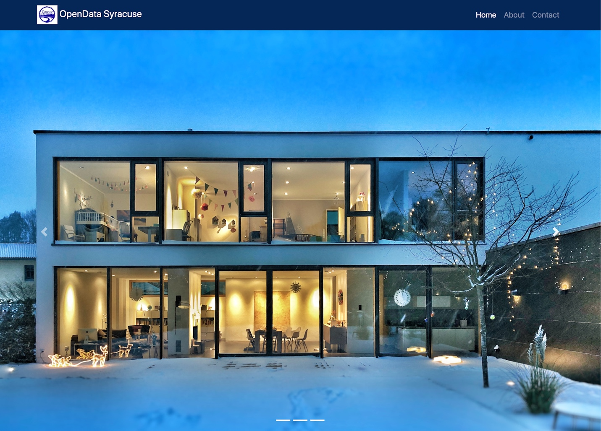

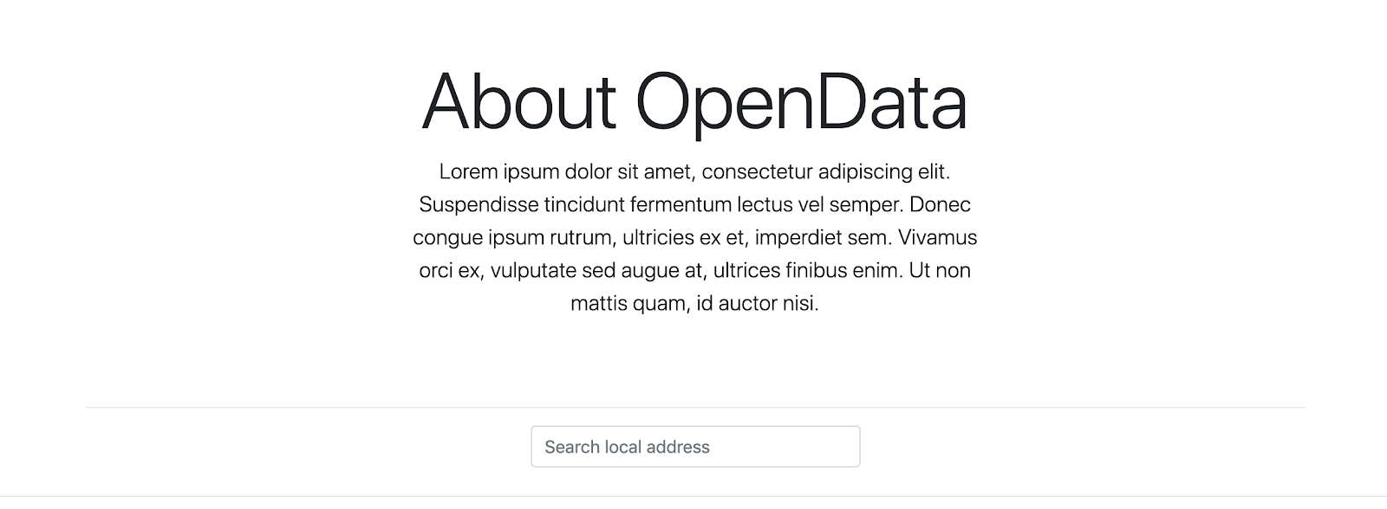

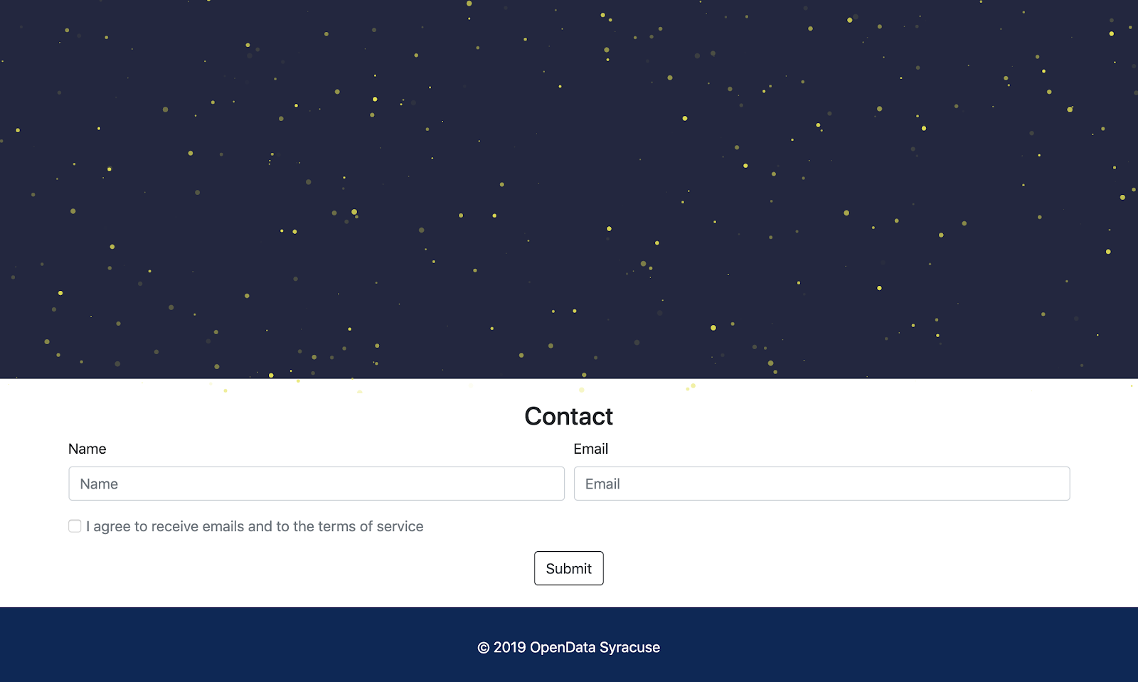

The interface has several parts:

* The navigation bar
* Carousel featured image section
* Open Data Syracuse introduction area
* Search Bar
* Canvas for returning results
* Contact form
* Footer

Testing

Environment and Software:

* Visual Studio Code(version 1.33.1) with Live Server Extension(by Ritwick Dey).
* Google Chrome Browser(version 73.0.3683)

We use Sam’s updated Parcel API address to ensure the address will be fetched from the bigger data set. We kept the second API address that the previous developer used. We input the same address and hit the “Enter”, the new version of web app returns result as same as the original version, which indicates the original function was kept.

However, there is also one limitation. By simply opening two API’s address and comparing address information and violation information, it is hard to find out which database is more updated. We assumed that  Sam’s Parcel API address can give the most updated registered home address information, but we cannot know if it is the most updated one.

When a user inputs an address, and the returning result is “No Code Violation History Founded”, there are two situations. The first situation is that the address does not exist in the first address fetching API, and the address does not exist in the second code violation history fetching API. We can conclude that the housing address is not registered in the system and it should be marked as a red flag.  The second situation is that the address exists in the first address feting API, which means the autocomplete function runs successfully, however, there is no code violation history in the system. This is what a user wants to see because it indicates the house is registered and there is no violation. It is a green flag.

Future Improvements for Next Intern Group

 1: Innovate the web design - There could be more sections for rich content, for example, a section about why OpenDataSyraucse is better than other platforms.

 2: Improve search bar function - Instead of showing weights in the resulting result, showing letter grade in the drop-down list like in “RentLogic” would be better.

 3: Improve API use - It is unnecessary to write a file and read from it whenever connected with API.

**Appendix**  
1. jQueryUI Autocomplete address:

*https://jqueryui.com/autocomplete/*

2. The Parcel housing address API:

*“https://services6.arcgis.com/bdPqSfflsdgFRVVM/arcgis/rest/services/Code_violations/FeatureServer/0/query?where=1%3D1&outFields=*&outSR=4326&f=json”.*

3. The housing violation history API:

*“https://services6.arcgis.com/bdPqSfflsdgFRVVM/arcgis/rest/services/Code_violations/FeatureServer/0/query?where=UPPER(property_address)%20like%20%27%25%25%27&outFields=property_address,property_zip,property_id,violation_name,violation_date,violation_status,case_number,case_type,property_id,property_owner_name&returnGeometry=false&outSR=4326&f=json”*